Test Case: tc001_SPX_Dev5_Crear_Requisicion_Spot_Tipo_Cobro_CC
Step 1 - Enter username and password and click to button Enter : Credentials Entered
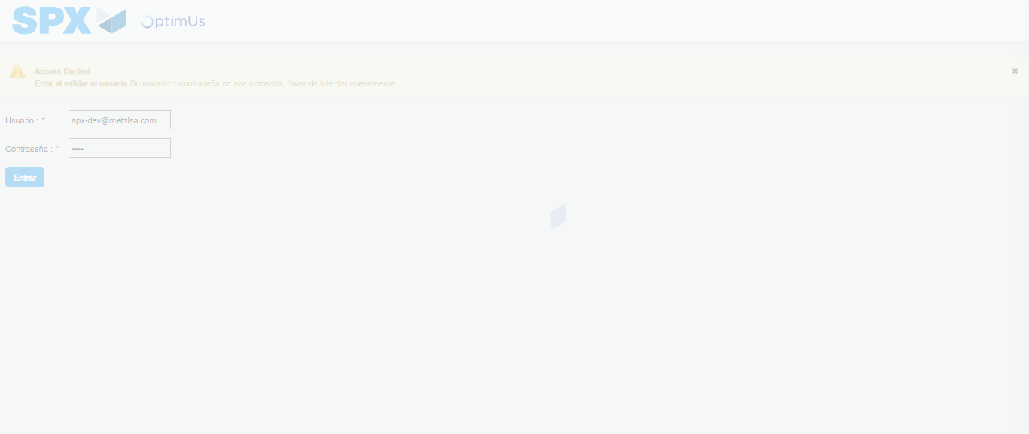Image file-name: QC_Testing-tc001_SPX_Dev5_Crear_Requisicion_Spot_Tipo_Cobro_CC-1788297908067

Step 2 - Select to UEN and Access to Spot Buy Requisitions : UEN Correctly selected and Correct access
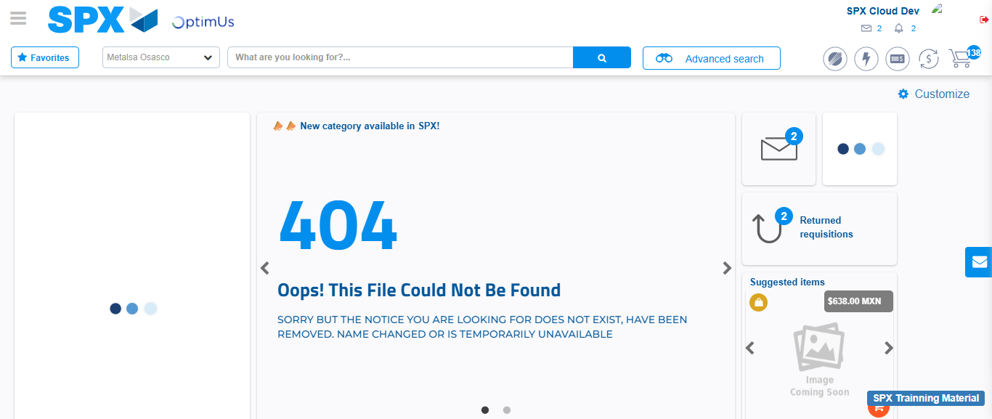Image file-name: QC_Testing-tc001_SPX_Dev5_Crear_Requisicion_Spot_Tipo_Cobro_CC-1788297935094

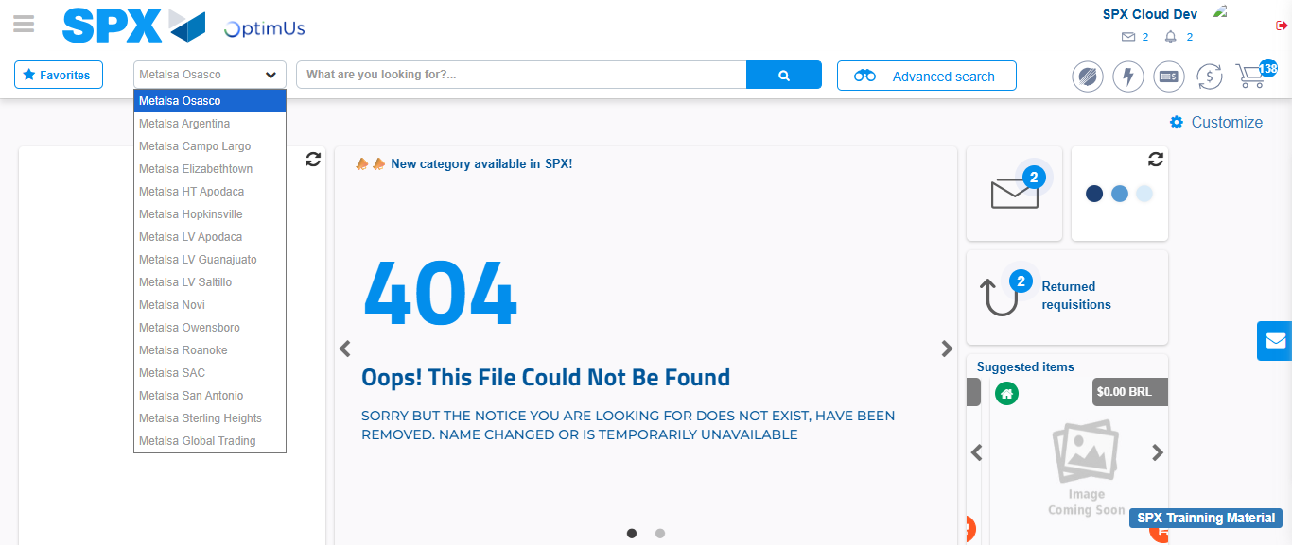Image file-name: QC_Testing-tc001_SPX_Dev5_Crear_Requisicion_Spot_Tipo_Cobro_CC-1788297935735

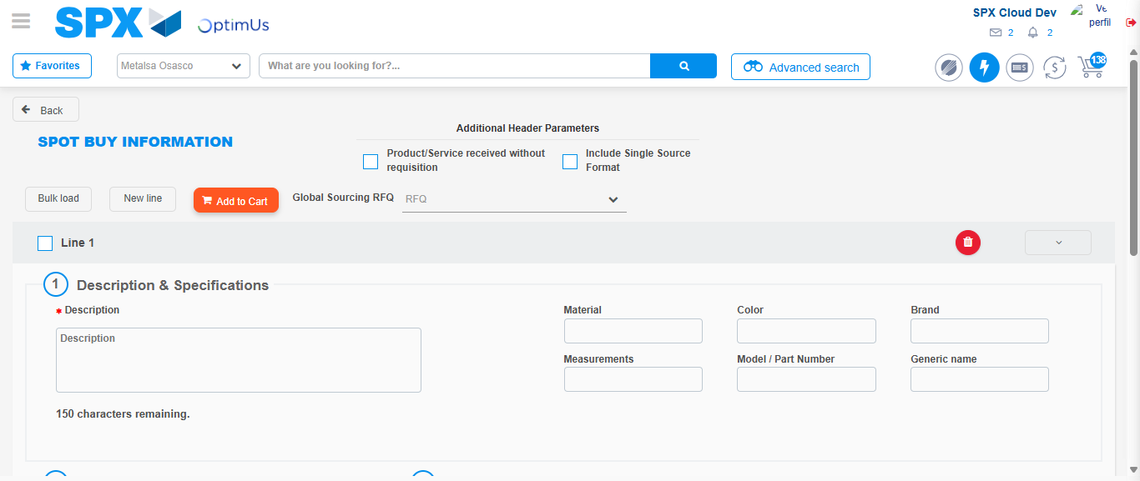Image file-name: QC_Testing-tc001_SPX_Dev5_Crear_Requisicion_Spot_Tipo_Cobro_CC-1788297952218

Step 3 - Data Capture Spot Buy Requisition : Data captured correctly
Image file-name: QC_Testing-tc001_SPX_Dev5_Crear_Requisicion_Spot_Tipo_Cobro_CC-1788297952528

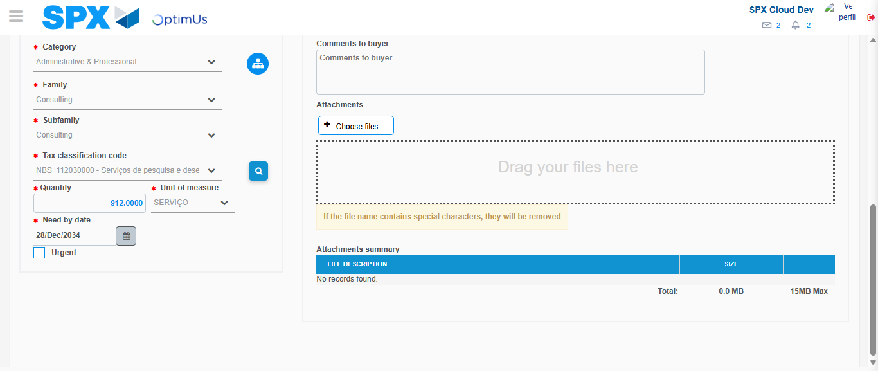Image file-name: QC_Testing-tc001_SPX_Dev5_Crear_Requisicion_Spot_Tipo_Cobro_CC-1788297967297

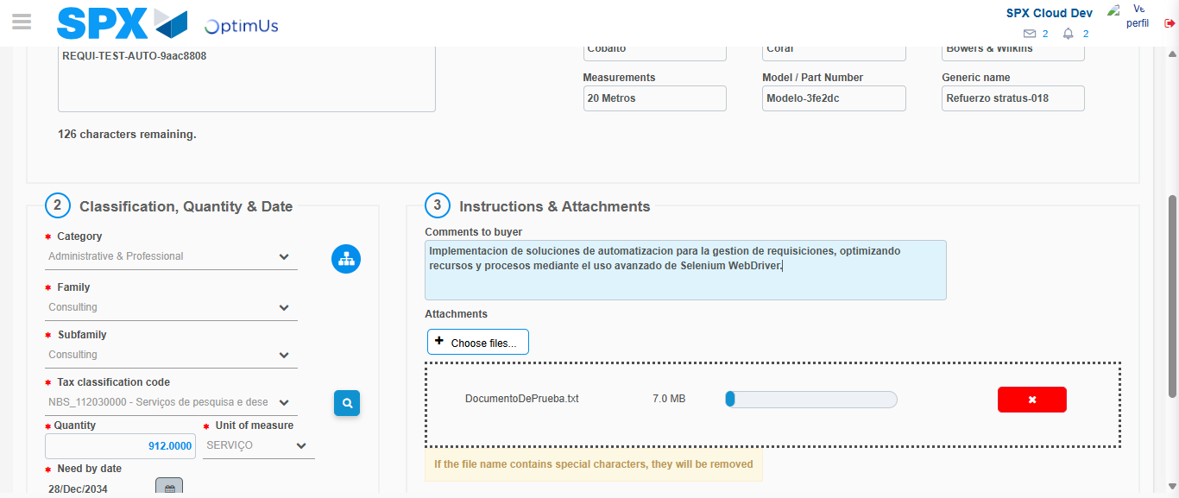Image file-name: QC_Testing-tc001_SPX_Dev5_Crear_Requisicion_Spot_Tipo_Cobro_CC-1788297968150

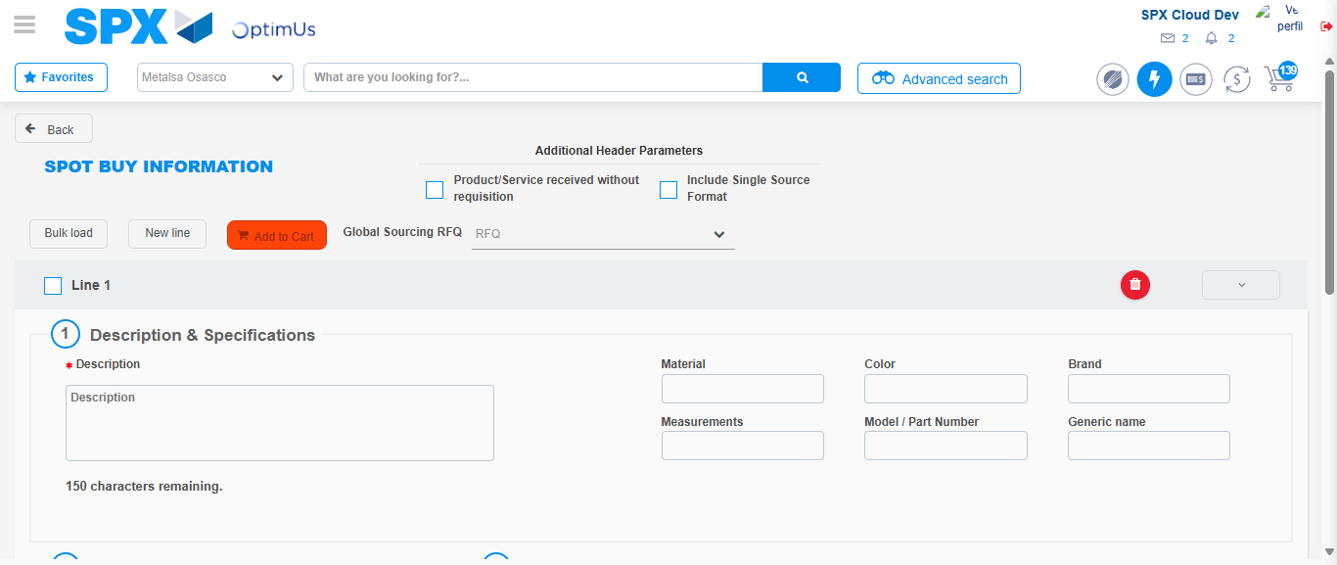Image file-name: QC_Testing-tc001_SPX_Dev5_Crear_Requisicion_Spot_Tipo_Cobro_CC-1788297975328

Step 7 - Return to Main Page SPX : Return to Main Page SPX
Image file-name: QC_Testing-tc001_SPX_Dev5_Crear_Requisicion_Spot_Tipo_Cobro_CC-1788297935094

Image file-name: QC_Testing-tc001_SPX_Dev5_Crear_Requisicion_Spot_Tipo_Cobro_CC-1788297935735

Image file-name: QC_Testing-tc001_SPX_Dev5_Crear_Requisicion_Spot_Tipo_Cobro_CC-1788297952218

Image file-name: QC_Testing-tc001_SPX_Dev5_Crear_Requisicion_Spot_Tipo_Cobro_CC-1788297977604

Image file-name: QC_Testing-tc001_SPX_Dev5_Crear_Requisicion_Spot_Tipo_Cobro_CC-1788297977881

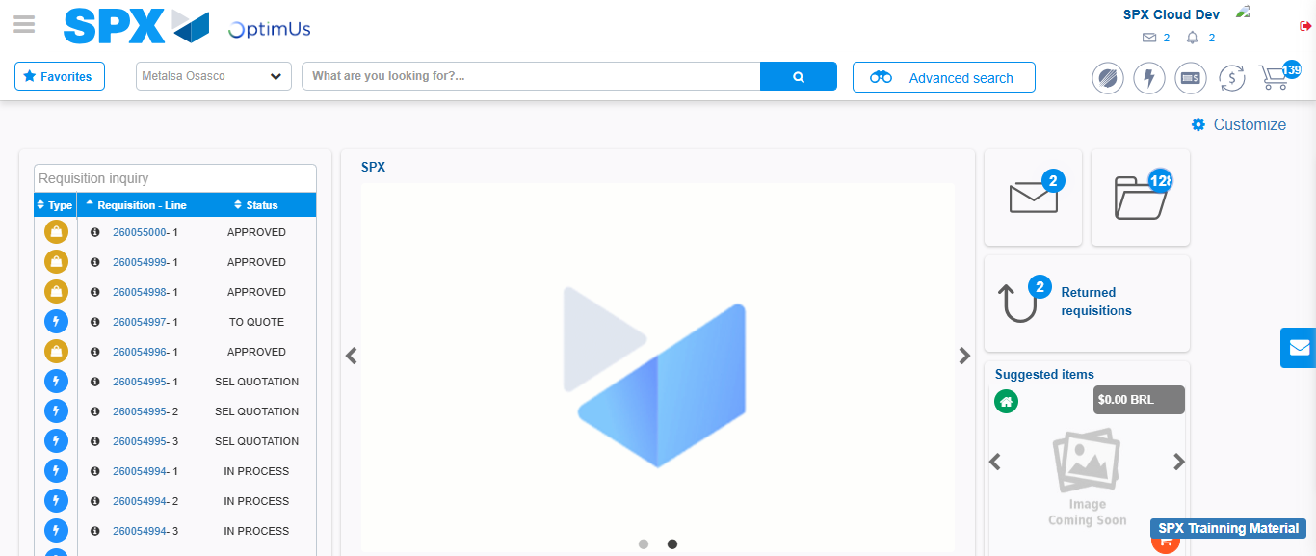Image file-name: QC_Testing-tc001_SPX_Dev5_Crear_Requisicion_Spot_Tipo_Cobro_CC-1788297999029

Step 8 - Log Out : Log Out SPX
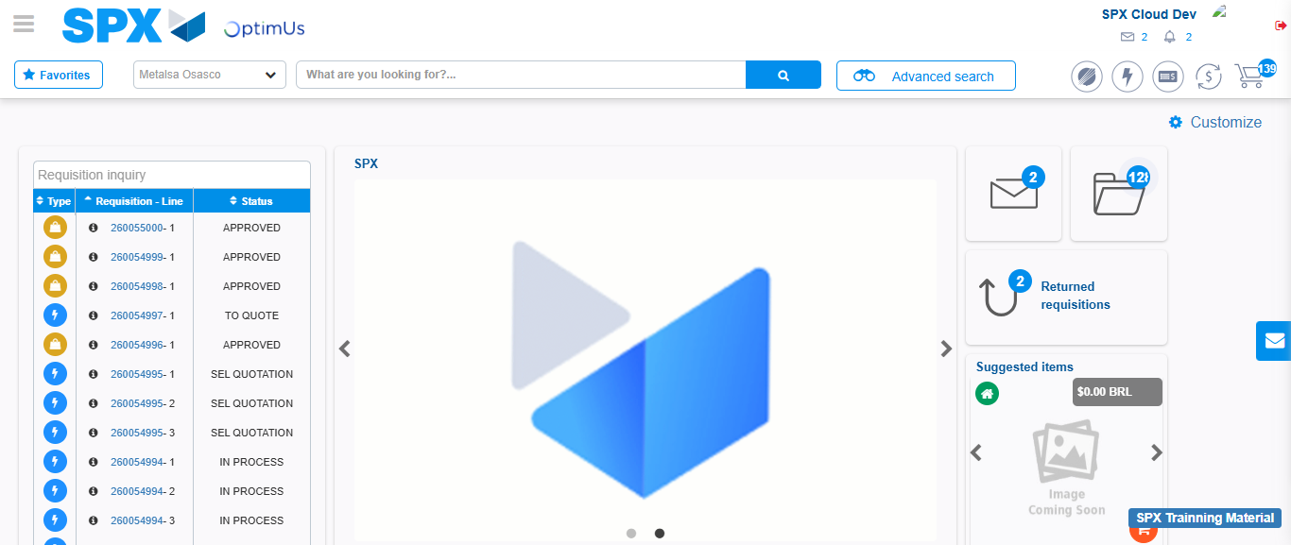Image file-name: QC_Testing-tc001_SPX_Dev5_Crear_Requisicion_Spot_Tipo_Cobro_CC-1788297999364

